**AProjectReport**

**on**

**“AGRO FLEET”**

Submitted in partial fulfillment of the requirements

For the award of the degree of Bachelor of Technology in

Computer Science & Engineering



AKS UNIVERSITY, SATNA

**B.Tech (CSE) 4thSemester**

#### Submitted by:-

#### Aman Shukla (B2355R10106104)

#### Prakash Soni (B2355R10106141)

**Under The Guidance of:- Approved by:-**

Mr. Pushpendra Bhatt Prof. Dr.Akhilesh A. Waoo

(Assistance Professor) (Associate Dean & Head CS/IT)

**Department of Computer Science & Engineering**

**AKS University, Satna (M.P.)**

## CERTIFICATE

This certify that the project report entitled “AGRO FLEET” submitted by partial fulfilment of the requirement for the degree of Bachelor of Technology in Computer Science & Engineering in

Jan-Jun 2025 AKS University, Satna is a bonafide project work carried out by Sweksha Soni (B2355R10106172) & Dharmendra Narendra Singh (B2355R10106177), under my supervision. The subject of the project report has been approved by supervisor. This is also to certify that it is their original work and no part of this project is report has been submitted for any other degree/diploma.

All the assistance and help received during the course of the investigation has been duly acknowledged.

1. I satisfied that the report presented by Sweksha Soni & Dharmendra Narendra Singh is worthy of consideration for award of the degree.
2. I certify:
   1. That they pursued the prescribed course of research.
   2. That they bear good moral character.

Place: AKSU, Satna

Date:…/…./………

………………………… ………………………… ………………………...

Supervisor Head of Department External Signature

(Mr. Pushpendra Bhatt) (Prof.Dr. Akhilesh A.Waoo)

(Assistant Professor) (Associate Dean & Head CS/IT)

**CERTIFICATE BY THE CANDIDATE**

We certify that the project report entitled “AGRO FLEET” is our own work conducted under the supervision of Mr. Pushpendra Bhatt (Supervisor), Department of Computer Science, AKS University, Satna (M.P.) for partial fulfillment of the requirement for the degree in Bachelor of Technology in Computer Science & Engineering in Jan-Jun 2025.

We further certify that to the best of our knowledge and belief the project report does not contain any part of this work which has been submitted for the award of any degree either in this university or in any other University/ Deemed University/ Institutes.

* Prakasha Soni (B2355R10106141) - B.Tech 4th Semester
* Aman Shukla (B2355R10106104) - B.Tech 4th Semester

Place: AKSU, Satna

Date: …./…../………

………………………… …………………………..

Signature of Candidate Signature of Candidate

Prakasha Soni (B2355R10106141) Aman Shukla (B2355R10106104)

## SELF DECLARATION

We hereby declare that the work presented in this project entitled “AGRO FLEET" towards the partial fulfillment of the requirement for the award of Degree in B.Tech in Department of Computer Science, AKS University, Satna (M.P.) is an authentic record of our own work.

We have not submitted the matter embodied in the project for the award of any other degree or diploma to any other institute or university.

………………………… …………………………..

Signature of Candidate Signature of Candidate

Aman Shukla (B2355R10106104) Prakash Soni (B2355R10106141)

## 

## ACKNOWLEDGEMENT

It is a great for us to taking this opportunity to express our sincere thanks and ineptness to

Prof. Dr. Akhilesh A. Waoo, Head of the Department of CS/IT AKS University, Satna (M.P.)

We consider ourself lucky enough to have such a great project. This project would add as an asset to our profile.

At this moment of accomplishment, first of all we pay homage to our guide, from to Mr. Pushpendra Bhatt, Assistant Professor AKS University Satna (M.P.). This work would not have been possible without his guidance, support and encouragement. Under his guidance we successfully overcame many difficulties and learned a lot.

We deeply and forever indebted to our parents for their love, support and encouragement throughout my entire life.

**ABSTRACT**

**“Agro Fleet**” is a smart, user-centric platform designed to simplify the process of renting agricultural machinery and equipment. Targeting farmers and agricultural service providers, the system provides a streamlined interface where users can search for equipment based on key parameters such as location, rental cost, equipment type, availability, and user ratings. The platform integrates interactive maps, real-time availability, and verified listings to ensure reliability and ease of use. Leveraging technologies such as geolocation, secure authentication, and data filtering, Agro Fleet reduces the time and effort involved in traditional equipment rental methods. It also allows equipment owners to list their machines, manage bookings, and communicate securely with potential renters. The project aims to bridge the gap between farmers in need of machinery and those who can provide it, promoting transparency, safety, and efficiency in the agricultural rental process.

"Agro Fleet" is a next-generation agricultural equipment rental platform designed to transform the traditional machinery access process into a smart, seamless experience. Born out of the everyday challenges faced by farmers and agribusinesses, this project reimagines the way agricultural tools and machines are rented for short or long-term use. By combining geolocation intelligence, personalized recommendations, and verified user profiles, "Agro Fleet" curates equipment listings tailored to specific farming needs—filtering by budget, machine type, availability, and proximity to the user's location.

More than just a listing service, the platform acts as a digital bridge between equipment renters and owners, incorporating real-time availability, secure communication, digital rental agreements, and AI-driven fraud detection to foster trust and transparency. With an intuitive UI and a mobile-first design, the application empowers farmers to make informed, confident decisions without the hassle of traditional rental searches. "Agro Fleet" is not just about finding machinery—it's about finding the right equipment, from the right provider, at the right time.

## TABLE OF CONTENT

* Introduction……...…………………………………………………………..1
* Objective of The Project…………………………………………………....2
* Scope of The Projects…..…………………………………………………...3
* Definition of Problem………………………………………………………4
* Benefit of The Projects …………………………………………………….5
* Main Module………………………………………………………………..6
* Technical Overview………………………………………………………...7
* System Configuration…..…………………………………………………..8
* Block Diagram…………………………………………………….………..9
* ER Diagram …..……………………………………………………………10
* Output Screen …..………………………………………………………….11
* Project Explanation…………………………………………………………12
* Coding……….……………..……………………………………………….13
* Software Testing ……………………………………………………………14
* Conclusion…………………………………………………………………..15

**INTRODUCTION**

Finding the right agricultural equipment—whether for short-term tasks or long-term projects—can be a stressful, time-consuming challenge, especially for farmers who lack access to resources or are unfamiliar with local rental options. The traditional equipment rental market often lacks transparency, is hard to navigate, and may expose users to unreliable or overpriced listings. **"Agro Fleet"** aims to solve these challenges by offering a digital platform that streamlines the equipment rental process through verified listings, smart filters, geolocation, and secure communication. This project bridges the gap between farmers and equipment owners, creating a trusted and efficient ecosystem for both parties.

In a world where agricultural demands are growing and access to modern machinery is critical, the need for flexible, trustworthy, and efficient equipment rental solutions has never been greater. Whether it's a small-scale farmer needing a tractor for seasonal work, a grower preparing land with specialized tools, or an agribusiness seeking short-term machinery, the search for reliable equipment often becomes a frustrating maze of outdated listings, misleading advertisements, and unreliable intermediaries.

**"Agro Fleet"** is born from this everyday struggle—with a mission to re-imagine farm equipment renting as a smart, stress-free experience. It’s more than just an app or a website; it’s a digital companion that understands farmers’ needs, learns their preferences, and connects them with the right tools for the job. By merging technology with trust, and simplicity with intelligence, this project aims to bring clarity and convenience to one of farming’s most critical needs: access to reliable machinery.

**OBJECTIVE OF THE PROJECT**

"Agro Fleet" is a web- and mobile-based application designed to help farmers discover available agricultural machinery and equipment based on their preferences such as location, rental cost, equipment type, condition, and duration of use. Equipment owners can list their machines with detailed descriptions, photos, and pricing, while users can browse, compare, and connect directly with owners. The system incorporates modern features like:

* Real-time equipment availability
* Map-based search
* Advanced filters (rent, location, amenities)
* User verification and reviews
* In-app messaging between renters and owners
* Smart suggestions based on user behavior

The platform is designed to be intuitive, secure, and responsive to the needs of both sides of the rental market.

**SCOPE OF THE PROJECT**

The scope of the "Agro Fleet" project includes:

The **"Agro Fleet"** project is designed as a scalable, user-friendly platform that facilitates seamless connections between farmers and agricultural equipment owners. The system will function as both a web and mobile application, targeting users who need machinery for short-term tasks or long-term projects..

1. **User Registration and Profile Management:**

* Secure sign-up/login for equipment seekers and landlords.
* Profile creation with basic details, preferences, and verification.

1. **Equipment Listing and Management for Owners:**
   * Interface to add, update, or remove machinery and equipment listings.
   * Ability to upload images, set rental prices, specify equipment condition, and availability.
2. **Search and Discovery Features:**

* Advanced search filters (location, price range, amenities, availability, etc.).
* Map-based equipment discovery with geolocation support.
* Smart suggestions based on user preferences and history.

1. **Communication and Booking System:**

* In-app messaging between renters and equipment owners.
* Request and confirm room bookings.
* Optional integration for digital rental agreements and booking history.

1. **Ratings and Reviews:**

* Feedback system to rate equipment and rental experiences.
* Review moderation to ensure quality and build trust.

1. **Admin Panel:**

* Centralized dashboard to monitor users, listings, complaints, and reports.
* Tools for content moderation and fraud detection.

Future expansions may include AI-based equipment matching, automated lease generation, and payment gateway integration.

**DEFINITION OF THE PROBLEM**

**"Agro Fleet"** is a digital platform—available as both a web and mobile application—designed to streamline the process of searching for, listing, and renting agricultural machinery and equipment. The project aims to create a centralized, user-friendly system where farmers can discover verified rental options based on their needs, and equipment owners can efficiently list and manage their machines.

Despite the growing demand for flexible, affordable access to agricultural machinery, the current solutions remain fragmented, inefficient, and unreliable. Farmers are often forced to rely on word-of-mouth, local contacts, or scattered advertisements—none of which guarantee availability or fair pricing. Likewise, equipment owners struggle to reach genuine renters without incurring heavy costs or dealing with unreliable intermediaries.

There is a clear need for a centralized, trustworthy, and intelligent platform that simplifies the agricultural equipment rental process for both farmers and equipment owners, ensuring convenience, transparency, and security.

**BENEFITS OF THE PROJECT**

### **For Farmers (Renters):**

**Convenience & Accessibility**

* Farmers can search for machinery and equipment from anywhere, at any time, using their mobile devices or web browsers.
* No need to physically visit dozens of locations—filter and shortlist options instantly.

#### **Personalized Search Experience**

* Advanced filters (location, rental cost, equipment type, availability, and condition) tailor results to farmers’ specific needs.
* AI-powered suggestions based on user behavior and past activity.

#### **Transparency & Trust**

* Verified equipment listings with real photos, detailed descriptions, and owner verification reduce the risk of fraud.
* Review and rating systems allow users to see feedback from previous renters, building trust and confidence.

#### **Time-Saving**

#### Real-time equipment availability prevents the hassle of contacting owners for already-rented machinery.

#### Instant messaging and booking requests streamline communication between farmers and equipment owners.

#### **Improved Safety**

* Verified profiles and in-app communication reduce the risk of scams and personal security threats.
* Optional features like equipment usage guides and compatibility checks help farmers choose the right machinery for their specific tasks.

### For Machinery Owners (Farmers/Providers):

#### Efficient Equipment Management

* Simple tools to list, update, or remove machinery availability.
* Instant alerts for booking requests and inquiries.

#### **Direct Communication**

* In-app chat enables clear, direct conversations with renters—no middlemen involved.

#### Faster Equipment Utilization

* Real-time updates and smart matching features help your machines get rented faster.
* Reduced idle time means more income and better equipment usage.

### **Social and Economic Impact:-**

#### Empowering Small Farmers & Rural Communities

* Helps farmers with limited budgets access affordable, verified farming equipment easily.
* Encourages secure and inclusive access to machinery, especially in remote villages and agricultural regions.

#### Boosting Rural Economies

* Increased utilization of rental equipment stimulates local agri-based economies, especially in underdeveloped and semi-urban farming zones.

#### Reducing Agricultural Inequality

* Brings structure to informal equipment sharing, ensures fair rental pricing, and promotes awareness about modern farming practices and farmer rights.

### **3. Future Scalability &Innovation:-**

#### **Modular Expansion**

* Scope to integrate payment gateways, digital rental agreements, user verification, and smart booking systems.
* Can be extended to include tractor pooling, drone services, harvest-sharing models, or even B2B agri-equipment leasing.

#### **Smart Ecosystem Integration**

* Potential to connect with IoT-enabled machinery for real-time usage tracking, maintenance alerts, and automated rental logs.

**MAIN MODULES**

## **Main Modules of “Agro Fleet” Project – In Detail**

### **1. User Authentication & Profile Management Module**

#### **Key Features:**

* User registration with email/mobile verification
* Login/logout functionality
* Role-based access (tenant or landlord)
* Password encryption and reset options
* Profile creation (name, photo, contact info, preferences)
* Identity verification (optional: ID upload or KYC)

### **2. Equipment Listing & Management Module**

#### **Key Features:**

* Add new listings with title, description, rent price, equipment photos, location  
  Include filters: equipment type (tractor, harvester, rotavator, etc.), usage type, horsepower.
* Mark listings as available/unavailable
* Set booking rules (minimum rental duration, usage limitations, etc.)

### **3. Search & Filter Module**

#### **Key Features**

#### Location-based search (with map view for nearby available machines)

* Filters: rental budget, equipment type, brand, horsepower, availability
* Sort by rental price, proximity, reviews, equipment condition
* Save favorites or bookmark preferred machines

### **4. Booking & Request Module**

#### **Key Features:**

* “Request to Rent” functionality
* Machinery owner approval/rejection system
* Rental calendar or availability time slotsView booking history
* Cancellation and confirmation options

### **5. Reviews & Rating Module**

#### **Key Features:**

* 5-star rating system
* Comment section for reviews
* Review moderation by admin
* View average ratings on listings and user profiles

## ****TECHNICAL OVERVIEW****

## **Technical Overview of "Agro Fleet":-**

### **System Architecture**

* **Frontend (Client Side)** – Developed using:
  + **HTML5** – Structure of the web pages
  + **CSS3** – Styling and layout
  + **JavaScript** – Frontend interactivity and dynamic content
* **Backend (Server Side)** – Powered by **PHP**, responsible for:
  + Handling form submissions, user sessions, and authentication
  + Processing data from the frontend
  + Performing CRUD operations (Create, Read, Update, Delete)
* **Database Layer** – MySQL is used for:
  + Storing user accounts, room listings, bookings, reviews, and messages

### **Frontend Technologies**

#### HTML5:

* Structure of UI components: navigation bars, forms, listings, modals, etc.

#### CSS3:

* Responsive design using media queries or frameworks like **Bootstrap**
* Custom UI styles for user profiles, cards, and room listings

#### JavaScript:

* Input validation (e.g., required fields, email formats)
* UI enhancements like image sliders, dynamic filters, and AJAX-based data fetching
* Client-side form validation and feedback

### **Backend Technologies**

#### PHP (Core + Procedural or OOP):

* Handles all backend logic (e.g., login, room submission, filtering)
* Communicates with MySQL to perform database queries
* Manages sessions, form handling, error reporting, and redirects

#### Example PHP Functionalities:

* register.php – Handles user registration
* login.php – Verifies credentials and starts session
* add_tractor.php – Landlords post new equipment
* search_baar.php – Fetches filtered results
* booking.php – Handles booking requests
* messages.php – Messaging between users

### **Database Design (MySQL)**

#### Main Tables:

#### users: user_id, name, email, password, role, contact info

#### equipment: equipment_id, user_id, title, location, rent, description, amenities

#### bookings: booking_id, equipment_id, tenant_id, start_date, end_date, status

#### messages: message_id, sender_id, receiver_id, content, timestamp

#### reviews: review_id, equipment_id, user_id, rating, comment

Relationships:

* One user can list many equipment
* One equipment can have many bookings
* Bookings link equipment to tenants

The **HTML + CSS + JS + PHP + MySQL** tech stack makes **"Agro Fleet"** lightweight, cost-effective, and accessible for deployment on most web servers. It’s ideal for academic, startup, or small-business scenarios, with the ability to scale or modularize over time by adopting MVC frameworks like (PHP) or integrating APIs for maps, SMS, or payment.

**SYSTEM CONFIGURATION**

* 1. **Hardware Requirement:**

**Processor:** i7 and all (8th Gen or higher and all Gen).

**RAM:** Minimum 8GB (16GB recommended for optimal performance).

**Storage:** 256GB SSD (or higher for faster data processing).

**Operating System:** Windows all.

* 1. **Software Requirements:**

**Frontend:** HTML, CSS.

**Backend:** JavaScript.

**Database:** PHP

**Development Tools:** VS Code.

**Operating System:** Windows All.

**BLOCK DIAGRAM**

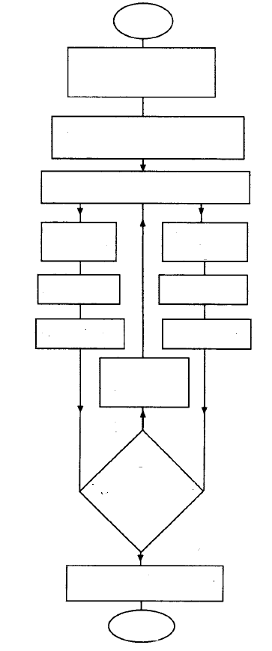

End

Go for Equipment

View Equipment

Home

Search Equipment

Home

Find Equipment

Home

Re-set Password

Forget password



Login

Register

Start

**ER DIAGRAM**

Key Entities and Attributes:

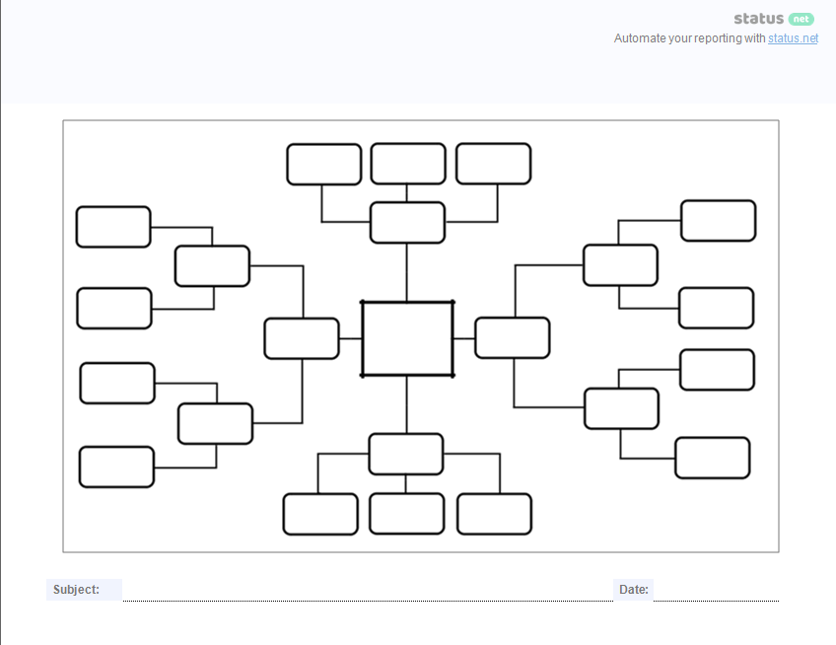

Go for Equipment

(Booking)

User name

User email

User phone number

User DOB

Rental duration

Additional note

Login

Equipment Details

Price

Location

Facilities

Owner name

Amenities

Description

Start

Tool

search

City

Area

Room Type

Budget

Regi-ster

Name

Number

Email

Location

Rent Price

Tool Image

Facilities

Description

Post

Equipment

(owner)

View

Equipment

User

Pass-

word

User

email

User

User

Pass-

word

User name,

User

email

**OUTPUT SCREEN**

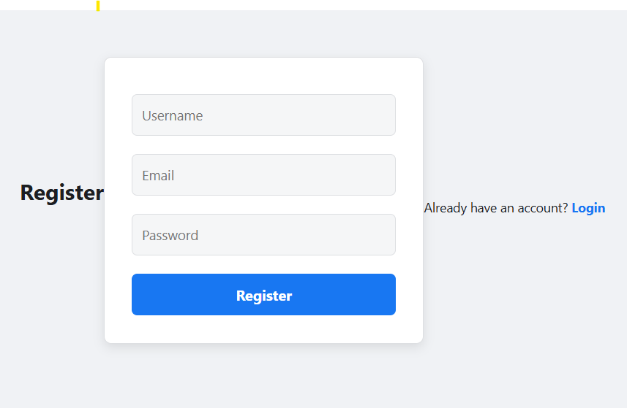

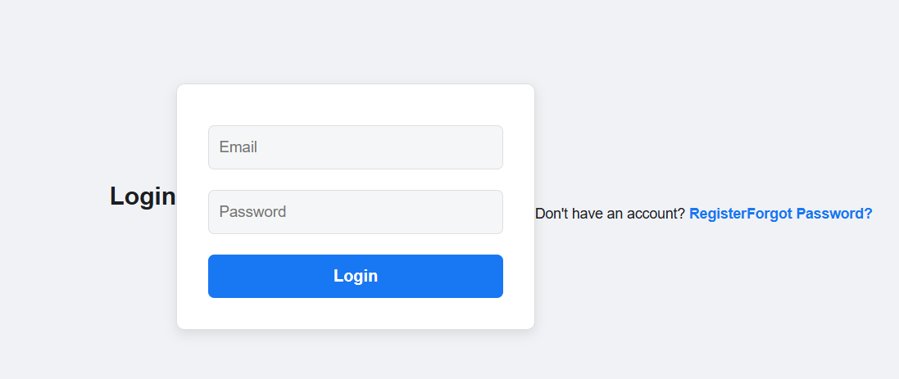

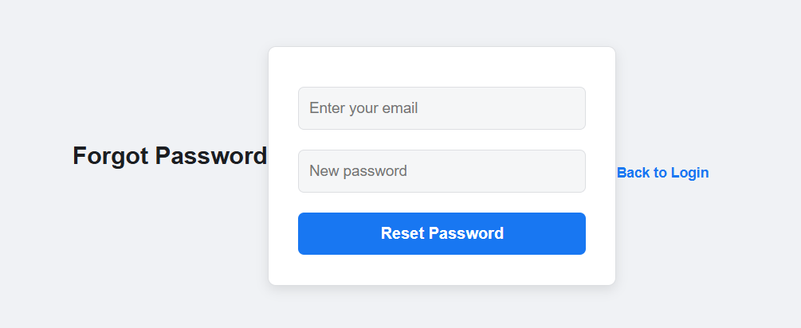

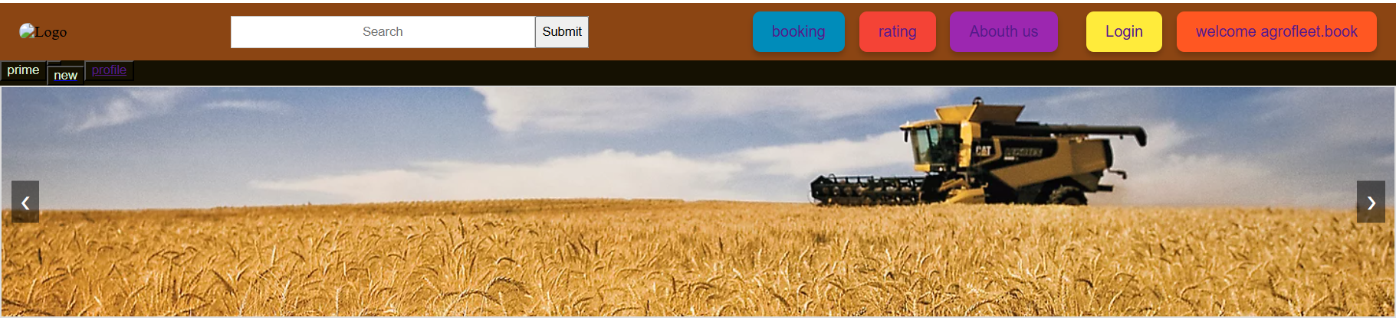

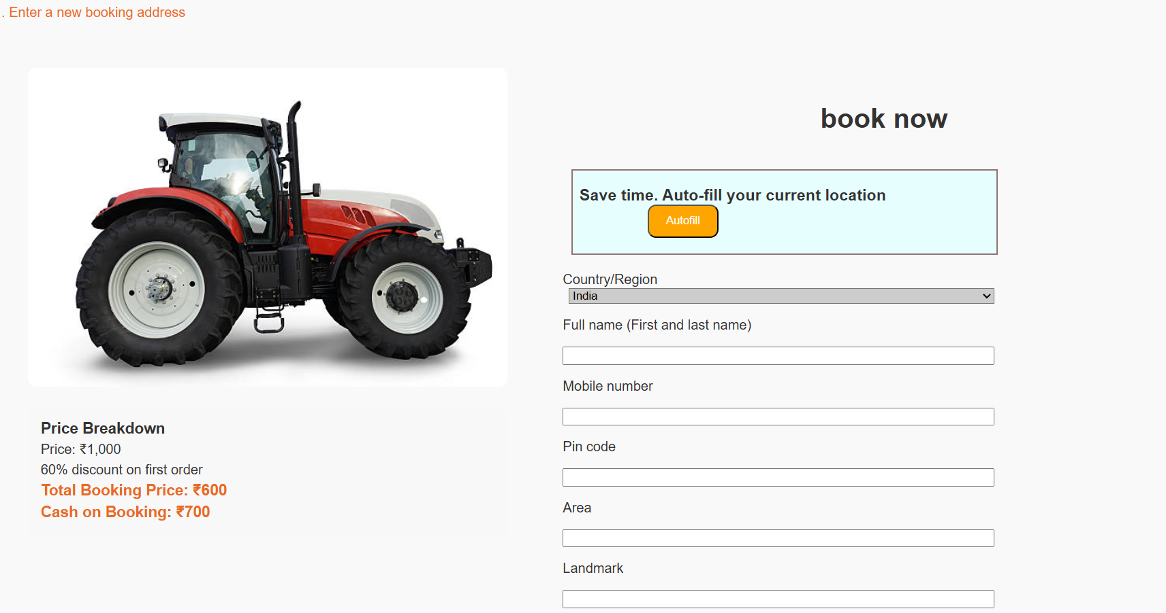

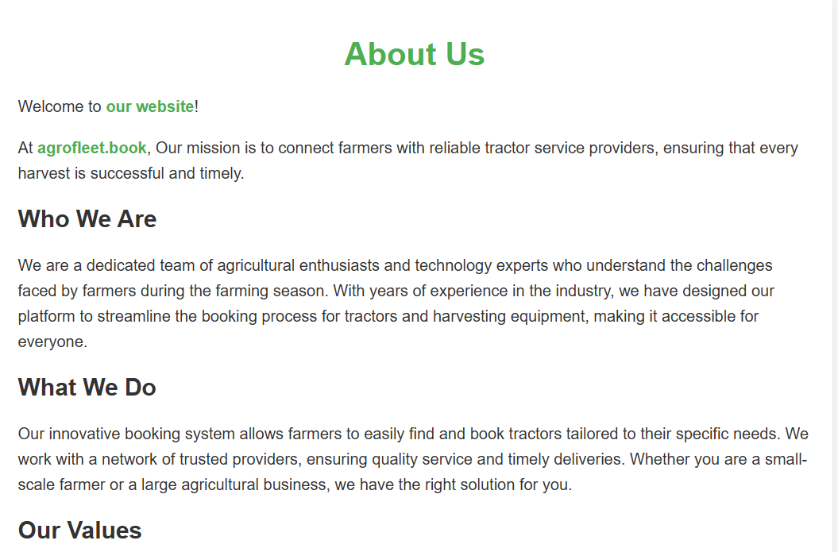

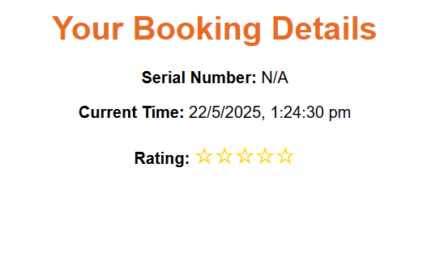



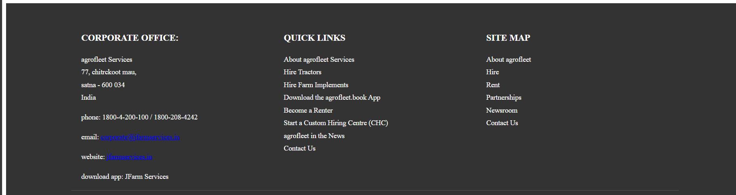

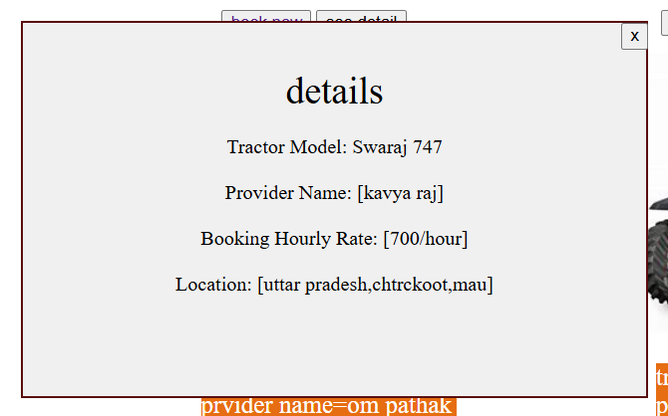

**PROJECT EXPLANATION**

**"Agrofleet**" is a web-based platform designed to help users — especially farmers and agri-entrepreneurs — easily rent agricultural machinery or post their own equipment for rent. The platform connects farmers in need of modern tools with equipment owners looking to maximize the utility and income of their machines.

* **Provide a user-friendly interface to search for available machinery based on location, budget, or equipment type.**
* **Allow machinery owners to post their equipment listings with complete details.**
* **Facilitate user interaction through features like wishlist, reviews, and ratings for equipment.**
* Enable a secure registration and login system for both equipment owners and renters.
* I can definitely help you add details like two-factor authentication, password recovery, email verification, or even biometric login options to make your system more secure and user-friendly.Build a centralized system that stores all data efficiently.

## ****How the System Works Together****

1. A user registers an account and logs in securely to access the Agrollet platform.
2. **A renter browses available machinery, applies filters, and adds preferred equipment to their wishlist.**
3. **An equipment owner posts a listing with images, detailed descriptions, and rental pricing.**
4. **Users can leave reviews and rate machinery after completing a rental.**
5. **Admin/support staff can respond to inquiries and messages from users promptly.**
6. All operations are powered by a MySQL database, managed via PHP backend, and displayed through a responsive HTML/CSS/JavaScript frontend..

## Example User Journey

1. **A renter visits the Agrollet website and registers an account.**
2. **They log in and search for available machinery in their preferred location.**
3. **"They view equipment details and add a few machines to their wishlist."**
4. Users reach out to the equipment owner or confirm their booking directly through the platform."After staying, they leave a review and rating.
5. **"Meanwhile, an owner logs in, adds new equipment listings, and manages their inventory."**

### 1. **Register & Login System**

Users (tenants or owners) can create an account and log in. Registration collects user data and stores it in the database. The login process checks credentials and starts a session for authenticated access.

### 2. **Find Equipment / Listings Page**

This section shows all available Tool or properties. Users can browse, search by city or price, and view details like photos, rent, and amenities. This data is fetched from the database and dynamically displayed.

### 3. **Services Section**

Describes what services the platform offers, such as:

* Verified listings
* Safe payments
* 24/7   
  It's a static section meant to build trust with users.

### 4. **Wishlist/Favorites**

Logged-in users can save Equipment they are interested in. These Tool are stored in a personal "wishlist" that the user can view and manage later. It's a convenience feature for tenants.

### 5. **About Us Section**

A static section that explains the purpose of the website — why it was built, who it helps (e.g., students, professionals), and what problems it solves (like finding trusted housing quickly).

### 6. **Reviews & Ratings**

Tenants can leave reviews and ratings for Equipment they’ve booked. This builds a reputation system where other users can see if a Tool is trustworthy and well-rated. Ratings are typically shown as stars or scores.

### 7. **Owner Posting Section**

Registered owners can post their available Tool. They fill in Tool details, upload photos, and submit it for display. These listings are stored in the database and shown on the Equipment listings page.

### 8. **Contact Us Section**

A simple form where users can reach out to the website admin or support team. It collects the user’s name, email, and message and either emails it or stores it in the database for later response.

## ****Technologies Used & Their Roles****

### 1. **HTML (HyperText Markup Language)**

HTML is used to **structure the content** of your web pages. It defines forms, buttons, headings, paragraphs, images, and more. For your project, it structures things like registration forms, Tool listings, reviews, and contact forms.

### 2. **CSS (Cascading Style Sheets)**

CSS is used to **style** the HTML content. It manages layout, colors, fonts, spacing, and responsiveness. It makes your website visually appealing — like giving the "Submit" button a red background or creating a clean layout for Tool listings.

### 3. **JavaScript**

JavaScript adds **interactivity** to your website. For example, it:

* Validates form inputs before submission
* Enables live search or filtering of Equipment
* Manages UI behaviors (e.g., modals, dropdowns, dynamic updates without page reload)

### 4. **PHP (Hypertext Preprocessor)**

PHP is a **server-side scripting language** used to handle backend logic. In your project, PHP:

* Processes form submissions (register, login, contact, etc.)
* Connects to the database to save or fetch data
* Manages sessions and user authentication
* Handles owner uploads and listings

### 5. **MySQL**

MySQL is the **database** system used to store all the site data, such as:

* User accounts
* Room listings
* Reviews and ratings
* Wishlist entries
* Messages from contact form

**PROJECT CODDING**

**Register.html**

<!DOCTYPE html>

<html>

<head>

  <title>Register</title>

</head>

<body>

  <style>

    /* style.css */

* {

  margin: 0;

  padding: 0;

  box-sizing: border-box;

  font-family: 'Segoe UI', Tahoma, Geneva, Verdana, sans-serif;

}

body {

  background-color: #f0f2f5;

  display: flex;

  justify-content: center;

  align-items: center;

  height: 100vh;

}

form {

  background-color: #ffffff;

  padding: 30px;

  width: 350px;

  border-radius: 8px;

  box-shadow: 0 4px 12px rgba(0, 0, 0, 0.1);

  text-align: center;

  border: 1px solid #dddfe2;

}

h2 {

  font-size: 24px;

  margin-bottom: 20px;

  color: #1c1e21;

}

input[type="text"],

input[type="email"],

input[type="password"] {

  width: 100%;

  padding: 12px 10px;

  margin: 10px 0;

  border: 1px solid #dddfe2;

  border-radius: 6px;

  font-size: 15px;

  background-color: #f5f6f7;

}

input:focus {

  border-color: #1877f2;

  outline: none;

  background-color: #fff;

}

button {

  width: 100%;

  padding: 12px;

  background-color: #1877f2;

  color: white;

  border: none;

  border-radius: 6px;

  font-size: 16px;

  font-weight: bold;

  cursor: pointer;

  margin-top: 10px;

}

button:hover {

  background-color: #166fe5;

}

p {

  margin-top: 15px;

  font-size: 14px;

  color: #1c1e21;

}

a {

  text-decoration: none;

  font-weight: bold;

  color: #1877f2;

}

a:hover {

  text-decoration: underline;

}

  </style>

  <h2>Register</h2>

  <form id="registerForm">

    <input type="text" placeholder="Username" name="username" required><br>

    <input type="email" placeholder="Email" name="email" required><br>

    <input type="password" placeholder="Password" name="password" required><br>

    <button type="submit">Register</button>

**Login.html**

<!DOCTYPE html>

<html>

<head>

  <title>Login</title>

  <link rel="stylesheet" href="style.css">

</head>

<body>

<form id="loginForm">

    <input type="email" placeholder="Email" name="email" required><br>

    <input type="password" placeholder="Password" name="password" required><br>

    <button type="submit">Login</button>

  </form>

  <p>Don't have an account? <a href="register.html">Register</a></p>

   <p><a href="forgot.html">Forgot Password?</a></p>

  <script src="/script.js"></script>

</body>

</html>

**Home.HTML**

<!DOCTYPE html>

<html lang="en">

<head>

    <meta charset="UTF-8">

    <meta name="viewport" content="width=device-width, initial-scale=1.0">

     <link rel="stylesheet" href="aman.css">

    <title>project ist</title>

</head>

<body>

    <div class="navbar">

        <div class="logo">

            <img src="https://th.bing.com/th/id/OIP.9S5Sg6x9t6j4sNHS4o46owHaHa?w=180&h=180&c=7&r=0&o=5&dpr=1.3&pid=1.7" alt="Logo">

        </div>

    <div class="search-container">

        <input type="text" placeholder="Search" id="search-bar">

       <input type="submit">

    </div>

        <div class="button-group">

            <button id="b"><a href="sa.html">booking</button></a>

            <button id="c"><a href="raja.html">rating</button></a>

            <button id="d"><a href="abouth.html">Abouth us</button></a>

            <a href="C:\Users\aman0\OneDrive\Desktop\working\working\dada.html ">

                <button id="e"><a href="dada.html">Login</button></a>

            </a>

            <button id="f"><a href="welcome.html" >welcome agrofleet.book</button></a>

        </div>

    </div>

<div class="near">

<div class="am"><button>prime</button></div>

<div class="am"><button><a href="offer.htm offer</button></div></a>

<div class="am"><button>new</button></div>

<div class="am"><button><a href="profile.html">profile</button></div></a>

</div>

<div>

</div>

<div class="slider-container">

    <button id="prevBtn" class="slider-btn prev">❮</button>

    <img id="slideImage" src="" alt="Image Slider">

    <button id="nextBtn" class="slider-btn next">❯</button>

</div>

<div class="ui">

<img src="https://media.istockphoto.com/id/478958731/photo/tractor.jpg?s=612x612&w=0&k=20&c=alIX_9z1e_zlsZ7LkvOAznD_bpfmnonETzSqRcEcupM="id="ads">

<img src="https://cdn.pixabay.com/photo/2022/02/13/18/22/tractor-7011767_640.png"id="ads"style="margin-left:100px;">

<img src="https://cdn.pixabay.com/photo/2020/07/14/21/39/tractor-5405838_640.png"id="ads">

</div>

<div class="iu">

<p id="sd">tractor name=swaraj 747<br>prvider name=om pathak<br></p>

<p id="s">tractor name=mahindra<br>prvider name=Amanshukla<br></p>

<p id="sg">tractor name=john deere<br>prvider name=vikram<br></p>

</div>

<div class="book">

<button><a href="BOOKING.html">book now</a></button>

<button onclick="popup()">see detail</button>

<div class="detail"style="display:none;">

    <button id="bot"onclick="remove()">x</button><p id="de"><a style="font-size: 30px;">details</a><br><br>

        Tractor Model: Swaraj 747<br><br>

        Provider Name: [om pathak]<br><br>

        Booking Hourly Rate: [700/hour]<br><br>

        Location: [uttar pradesh,chtrckoot,mau]<br>

     </p>

    </div>

<button id="za"><a href="BOOKING.html">book now</button></a>

<button onclick="popu()">see detail</button>

<div class="detai"style="display:none;">

    <button id="bot"onclick="remov()">x</button><p id="de"><a style="font-size: 30px;">details</a><br><br>

        Tractor Model: Swaraj 747<br><br>

        Provider Name: [Aman shukla]<br><br>

        Booking Hourly Rate: [700/hour]<br><br>

        Location: [uttar pradesh,chtrckoot,mau]<br>

     </p>

    </div>

<button id="df"><a href="BOOKING.html">book now</button></a>

<button onclick="pop()">see detail</button>

<div class="deta"style="display:none;">

    <button id="bot"onclick="remo()">x</button><p id="de"><a style="font-size: 30px;">details</a><br><br>

        Tractor Model: Swaraj 747<br><br>

        Provider Name: [kavya raj]<br><br>

        Booking Hourly Rate: [700/hour]<br><br>

        Location: [uttar pradesh,chtrckoot,mau]<br>

     </p>

    </div>

</div>

<div class="ui">

    <img src="https://media.sandhills.com/img.axd?id=5192319423&wid=&rwl=False&p=&ext=&w=700&h=700&t=&lp=15&c=True&wt=False&sz=Max&rt=0&checksum=ZSkiR7BvvOyRr5rjQMnQ8SBuk67nn7ET"id="ads">

    <img src="https://th.bing.com/th/id/OIP.-ojT_avp_nBAP7v6TGJXaAHaE7?w=284&h=189&c=7&r=0&o=5&dpr=1.3&pid=1.7"id="ad">

    <img src="https://th.bing.com/th/id/OIP.R-FkQ43R5vkvnXCyQVvvHwHaEo?w=299&h=187&c=7&r=0&o=5&dpr=1.3&pid=1.7"id="ads">

    </div>

    <div class="iu">

    <p id="sd">tractor name=swaraj 747<br>prvider name=om pathak<br></p>

    <p id="s">tractor name=swaraj 747<br>prvider name=om pathak<br></p>

    <p id="sg">tractor name=swarj 747<br>prvider name=om pathak<br></p>

    </div>

    <div class="book">

    <button><a href="BOOKING.html">book now</button></a>

    <button onclick="px()">see detail</button>

<div class="dx"style="display:none;">

    <button id="bot"onclick="rx()">x</button><p id="de"><a style="font-size: 30px;">details</a><br><br>

        Tractor Model: Swaraj 747<br><br>

        Provider Name: [Vikram chaudhari]<br><br>

        Booking Hourly Rate: [700/hour]<br><br>

        Location: [uttar pradesh,chtrckoot,mau]<br>

     </p>

    </div>

    <button id="za"><a href="BOOKING.html">book now</button></a>

    <button onclick="pzz()">see detail</button>

    <div class="dzz"style="display:none;">

        <button id="bot"onclick="rzz()">x</button><p id="de"><a style="font-size: 30px;">details</a><br><br>

            Tractor Model: Swaraj 747<br><br>

            Provider Name: [Shivansh mishra]<br><br>

            Booking Hourly Rate: [700/hour]<br><br>

            Location: [uttar pradesh,chtrckoot,mau]<br>

         </p>

        </div>

    <button id="df"><a href="BOOKING.html">book now</button></a>

    <button onclick="p()">see detail</button>

    <div class="d"style="display:none;">

        <button id="bot"onclick="r()">x</button><p id="de"><a style="font-size: 30px;">details</a><br><br>

            Tractor Model: Swaraj 747<br><br>

            Provider Name: [Rajesh sahu]<br><br>

            Booking Hourly Rate: [700/hour]<br><br>

            Location: [uttar pradesh,chtrckoot,mau]<br>

         </p>

        </div>

    </div>

    <div class="ui">

        <img src="https://th.bing.com/th/id/OIP.rb_5pWozovfFuI9fnd3njAHaF2?rs=1&pid=ImgDetMaing"id="ads"style="margin-left:100px">

        <img src="https://img.freepik.com/premium-vector/red-farming-tractor-with-big-wheels_549515-628.jpg?w=2000"id="ads">

        <img src="https://th.bing.com/th/id/OIP.MlsRs1YbT92yKZ-uT-MNqwHaEp?w=274&h=180&c=7&r=0&o=5&dpr=1.3&pid=1.7"id="ads">

        </div>

        <div class="iu">

        <p id="sd">tractor name=swaraj 747<br>prvider name=om pathak<br></p>

        <p id="s">tractor name=swaraj 747<br>prvider name=om pathak<br></p>

        <p id="sg">tractor name=swarj 747<br>prvider name=om pathak<br></p>

        </div>

        <div class="book">

        <button><a href="BOOKING.html">book now</button></a>

        <button onclick="poe()">see detail</button>

        <div class="dee"style="display:none;">

            <button id="bot"onclick="ree()">x</button><p id="de"><a style="font-size: 30px;">details</a><br><br>

                Tractor Model: Swaraj 747<br><br>

                Provider Name: [shubham]<br><br>

                Booking Hourly Rate: [700/hour]<br><br>

                Location: [uttar pradesh,chtrckoot,mau]<br>

             </p>

            </div>

        <button id="za"><a href="BOOKING.html">book now</button></a>

        <button onclick="pxx()">see detail</button>

<div class="da"style="display:none;">

    <button id="bot"onclick="reeee()">x</button><p id="de"><a style="font-size: 30px;">details</a><br><br>

        Tractor Model: Swaraj 747<br><br>

        Provider Name: [dharmender singh]<br><br>

        Booking Hourly Rate: [700/hour]<br><br>

        Location: [uttar pradesh,chtrckoot,mau]<br>

     </p>

    </div>

        <button id="df"><a href="BOOKING.html">book now</button></a>

        <button onclick="za()">see detail</button>

        <div class="za"style="display:none;">

            <button id="bot"onclick="zaa()">x</button><p id="de"><a style="font-size: 30px;">details</a><br><br>

                Tractor Model: Swaraj 747<br><br>

                Provider Name: [kumkum]<br><br>

                Booking Hourly Rate: [700/hour]<br><br>

                Location: [uttar pradesh,chtrckoot,mau]<br>

             </p>

            </div>

        </div>

    <div class="r">

<img src="https://th.bing.com/th/id/OIP.A6OWAf9h76fXlPXQukDuswHaHa?w=193&h=193&c=7&r=0&o=5&dpr=1.3&pid=1.7"id="rr">

<img src="https://th.bing.com/th/id/OIP.b8KIrB9cuDowh0hss1yTJAHaHa?w=179&h=180&c=7&r=0&o=5&dpr=1.3&pid=1.7"id="rr">

<img src="https://th.bing.com/th/id/OIP.bC9gNvqkKEZ-ERn6Wa8l_AHaHa?pid=ImgDet&w=179&h=179&c=7&dpr=1.3"id="rr">

<img src="https://th.bing.com/th/id/OIP.fn8VZFGmVpnFAuXGNWLCzwHaFG?w=262&h=180&c=7&r=0&o=5&dpr=1.3&pid=1.7"id="rr"style="height:205px">

<img src="https://th.bing.com/th/id/OIP.Hw18h09orjTXBAHmV7afVQHaEa?w=322&h=192&c=7&r=0&o=5&dpr=1.3&pid=1.7"id="rr"style="height:205px">

<img src="https://th.bing.com/th/id/OIP.8iRMJDO9uryOGUCfAthi2AHaHa?w=193&h=193&c=7&r=0&o=5&dpr=1.3&pid=1.7"id="rr">

    </div>

    <h1><marquee>Harvesting Machinery Showcase</marquee></h1>

    <div class="container">

      <div class="image-card" onclick="window.location.href='BOOKING.html';">

        <img src="https://th.bing.com/th/id/OIP.tPlOGk5PkMAlIt4Gd2Vb7QHaEu?w=291&h=185&c=7&r=0&o=5&dpr=1.3&pid=1.7" alt="Tractor 1">

        <div class="text-overlay">Swaraj 747</div>

      </div>

      <div class="image-card" onclick="window.location.href='BOOKING.html';">

        <img src="https://th.bing.com/th/id/OIP.6BtCzOEm0g9Ho0cT6G2bdgHaHa?pid=ImgDet&w=179&h=179&c=7&dpr=1.3" alt="Harvester 2">

        <div class="text-overlay">Harvester X9</div>

      </div>

      <div class="image-card" onclick="window.location.href='BOOKING.html';">

        <img src="https://media.sandhills.com/img.axd?id=5192319423&wid=&rwl=False&p=&ext=&w=700&h=700&t=&lp=15&c=True&wt=False&sz=Max&rt=0&checksum=ZSkiR7BvvOyRr5rjQMnQ8SBuk67nn7ET" alt="Tractor 3">

        <div class="text-overlay">John Deere 5085</div>

      </div>

      <div class="image-card" onclick="window.location.href='BOOKING.html';">

        <img src="https://th.bing.com/th/id/OIP.-nE16keIyA8QH3lAE10UIwHaFk?pid=ImgDet&w=179&h=134&c=7&dpr=1.3" alt="Harvester 4">

        <div class="text-overlay">Kubota Combine</div>

      </div>

    </div>

    <h1>more vechile avilable  on this web</h1>

    <div class="asa">

<div class="qee">

<img src="https://cdn.pixabay.com/photo/2020/07/14/21/39/tractor-5405838_640.png"id="op">

</div>

    <div class="qee">

        <img src="https://th.bing.com/th/id/OIP.DMvfibECyJ7yYLYdNiKskQHaFj?w=243&h=183&c=7&r=0&o=5&dpr=1.3&pid=1.7"id="op">

        </div>

        <div class="qee">

            <img src="https://th.bing.com/th/id/OIP.rrsBvFVbo7Vcv5hAdQ-iZwAAAA?w=238&h=180&c=7&r=0&o=5&dpr=1.3&pid=1.7"id="op">

            </div>

            <div class="qee">

                <img src="https://th.bing.com/th/id/OIP.XX2fbDHiLZbcJKZLwZjhgAHaHa?w=173&h=180&c=7&r=0&o=5&dpr=1.3&pid=1.7"id="op">

                </div>

    </div>

<br>

    <footer>

        <div class="footer-container">

            <div class="footer-column">

                <h3>CORPORATE OFFICE:</h3>

                <p>agrofleet Services<br>

                77, chitrckoot mau,<br>

                satna - 600 034<br>

                India</p>

                <p>phone: 1800-4-200-100 / 1800-208-4242</p>

                <p>email: <a href="aman0567@gmail.com">corporate@jfarmservices.in</a></p>

                <p>website: <a href="https://agrofleet.book.com">jfarmservices.in</a></p>

                <p>download app: JFarm Services</p>

            </div>

            <div class="footer-column">

                <h3>QUICK LINKS</h3>

                <ul>

                    <li><a href="#">About agrofleet Services</a></li>

                    <li><a href="#">Hire Tractors</a></li>

                    <li><a href="#">Hire Farm Implements</a></li>

                    <li><a href="#">Download the agrofleet.book App</a></li>

                    <li><a href="#">Become a Renter</a></li>

                    <li><a href="#">Start a Custom Hiring Centre (CHC)</a></li>

                    <li><a href="#">agrofleet in the News</a></li>

                    <li><a href="#">Contact Us</a></li>

                </ul>

            </div>

            <div class="footer-column">

                <h3>SITE MAP</h3>

                <ul>

                    <li><a href="#">About agrofleet</a></li>

                    <li><a href="#">Hire</a></li>

                    <li><a href="#">Rent</a></li>

                    <li><a href="#">Partnerships</a></li>

                    <li><a href="#">Newsroom</a></li>

                    <li><a href="#">Contact Us</a></li>

                </ul>

            </div>

        </div>

        <div class="footer-bottom">

            <p>&copy; 2022 agrofleet Services</p>

            <div class="social-icons">

                <a href="#"><img src="phone-icon.png" alt="Phone"></a>

                <a href="#"><img src="facebook-icon.png" alt="Facebook"></a>

                <a href="#"><img src="twitter-icon.png" alt="Twitter"></a>

                <a href="#"><img src="linkedin-icon.png" alt="LinkedIn"></a>

                <a href="#"><img src="instagram-icon.png" alt="Instagram"></a>

            </div>

        </div>

    </footer>

</body>

<script src="first.js"></script>

</html>

**Booking.html**

</head>

<body>

    <p style="color: rgb(235, 105, 35);">1. Enter a new booking address</p>

    <div class="container">

        <div class="left-side">

            <img src="https://media.istockphoto.com/id/478958731/photo/tractor.jpg?s=612x612&w=0&k=20&c=alIX_9z1e_zlsZ7LkvOAznD_bpfmnonETzSqRcEcupM=" alt="Booking Item">

            <div class="price-details">

                <h3>Price Breakdown</h3>

                <p>Price: ₹1,000</p>

                <p>60% discount on first order</p>

                <p class="total">Total Booking Price: ₹600</p>

                <p class="total">Cash on Booking: ₹700</p>

            </div>

        </div>

        <div class="right-side">

          <h1>book now</h1>

            <div class="b">

                <h3>Save time. Auto-fill your current location <button style="margin-left: 80px;">Autofill</button></h3>

            </div>

            <div class="c">

                <label for="country">Country/Region<br></label>

                <select id="country" style="width: 500px;">

                    <optgroup label="Asia">

                        <option value="india">India</option>

                        <option value="china">China</option>

                        <option value="japan">Japan</option>

                    </optgroup>

                    <optgroup label="Europe">

                        <option value="germany">Germany</option>

                        <option value="france">France</option>

                        <option value="italy">Italy</option>

                    </optgroup>

                    <optgroup label="Africa">

                        <option value="kenya">Kenya</option>

                        <option value="nigeria">Nigeria</option>

                        <option value="south-africa">South Africa</option>

                    </optgroup>

                </select>

                <div class="e">

                    <p>Full name (First and last name)</p>

                    <input type="text" id="fullName" style="width: 500px;">

                    <p>Mobile number</p>

                    <input type="text" id="mobileNumber" style="width: 500px;">

                    <p>Pin code</p>

                    <input type="text" id="pinCode" style="width: 500px;">

                    <p>Area</p>

                    <input type="text" id="area" style="width: 500px;">

                    <p>Landmark</p>

                    <input type="text" id="landmark" style="width: 500px;">

                    <p>Town/City</p>

                    <input type="text" id="townCity" style="width: 240px;" placeholder="Town/City">

                    <label for="cout" style="margin-left: 20px;">State</label>

                    <select id="cout" style="width: 220px;">

                        <optgroup label="Asia">

                            <option value="uttar-pradesh">Uttar Pradesh</option>

                            <option value="madhya-pradesh">Madhya Pradesh</option>

                            <option value="japan">Japan</option>

                        </optgroup>

                        <optgroup label="Europe">

                            <option value="germany">Germany</option>

                            <option value="france">France</option>

                            <option value="italy">Italy</option>

                        </optgroup>

                        <optgroup label="Africa">

                            <option value="kenya">Kenya</option>

                            <option value="nigeria">Nigeria</option>

                            <option value="south-africa">South Africa</option>

                        </optgroup>

                    </select>

                    <p><input type="checkbox" id="defaultAddress"><label for="defaultAddress">Make this my default address</label></p>

                    <p>Select Payment Method:</p>

                    <select id="paymentMethod">

                        <option value="cash">Cash on Delivery</option>

                        <option value="current">Current Payment</option>

                    </select>

                    <button onclick="showPaymentPopup()">submit</button>

                    <!-- Rating Section -->

                    <div class="rating">

                        <p>Rate Your Experience:</p>

                        <select id="rating">

                            <option value="">Select Rating</option>

                            <option value="1">1 Star</option>

                            <option value="2">2 Stars</option>

                            <option value="3">3 Stars</option>

                            <option value="4">4 Stars</option>

                            <option value="5">5 Stars</option>

                        </select>

                    </div>

                </div>

            </div>

        </div>

    </div>

    <!-- Overlay for popups -->

    <div class="overlay" id="overlay"></div>

    <!-- Payment popup -->

    <div class="popup" id="paymentPopup">

        <h2>Payment Confirmation</h2>

        <p>Please confirm your booking of ₹600. Click "Confirm" to proceed.</p>

        <button onclick="confirmPayment()">Confirm</button>

        <button onclick="closePopup('paymentPopup')">Cancel</button>

    </div>

    <!-- Welcome popup -->

    <div class="popup" id="welcomePopup">

        <h2>Welcome!</h2>

        <p>Your booking has been successfully confirmed!</p>

        <button onclick="closePopup('welcomePopup')">Close</button>

    </div>

<script>

function showPaymentPopup() {

    const inputs = document.querySelectorAll('.right-side input');

    let isFilled = true;

    // Check if all inputs are filled

    inputs.forEach(input => {

        if (!input.value) {

            isFilled = false;

        }

    });

    if (isFilled) {

        document.getElementById('overlay').style.display = 'block'; // Show overlay

        document.getElementById('paymentPopup').style.display = 'block'; // Show payment popup

    } else {

        alert("Please fill in all fields before submitting.");

    }

}

function confirmPayment() {

    // Save booking information to localStorage

    const bookingDetails = {

        fullName: document.getElementById('fullName').value,

        mobileNumber: document.getElementById('mobileNumber').value,

        pinCode: document.getElementById('pinCode').value,

        area: document.getElementById('area').value,

        landmark: document.getElementById('landmark').value,

        townCity: document.getElementById('townCity').value,

        state: document.getElementById('cout').value,

        paymentMethod: document.getElementById('paymentMethod').value,

        rating: document.getElementById('rating').value,

    };

    localStorage.setItem('bookingDetails', JSON.stringify(bookingDetails));

    // Close the payment popup and show the welcome popup

    closePopup('paymentPopup');

    document.getElementById('overlay').style.display = 'block'; // Show overlay

    document.getElementById('welcomePopup').style.display = 'block'; // Show welcome popup

    // Redirect to raja.html after a short delay

    setTimeout(() => {

        window.location.href = 'C:\Users\aman0\OneDrive\Desktop\working\working\raja.html'; // Redirect to the rating status page

    }, 2000); // 2-second delay before redirecting

}

function closePopup(popupId) {

    document.getElementById('overlay').style.display = 'none'; // Hide overlay

    document.getElementById(popupId).style.display = 'none'; // Hide specific popup

}

</script>

</body>

</html>

**Find Equipement.html**

<!DOCTYPE html>

<html lang="en">

<head>

    <meta charset="UTF-8">

    <meta name="viewport" content="width=device-width, initial-scale=1.0">

    <title>Booking Rating</title>

    <style>

        body {

            font-family: Arial, sans-serif;

            margin: 20px;

            text-align: center;

        }

        .rating {

            font-size: 24px;

            color: gold;

        }

        h1 {

            color: #e96a23;

        }

        .details {

            margin: 20px 0;

        }

    </style>

</head>

<body>

<h1>Your Booking Details</h1>

<div class="details">

    <p><strong>Serial Number:</strong><span id="serialNumber"></span></p>

    <p><strong>Current Time:</strong><span id="currentTime"></span></p>

    <p><strong>Rating:</strong><span class="rating" id="rating"></span></p>

</div>

<script>

    // Retrieve booking details from localStorage

    const bookingDetails = JSON.parse(localStorage.getItem('bookingDetails'));

    if (bookingDetails) {

        // Display the serial number (could be a unique identifier or just an incrementing number)

        const serialNumber = bookingDetails.serialNumber || 'N/A';

        document.getElementById('serialNumber').innerText = serialNumber;

        // Display the current time

        const currentTime = bookingDetails.currentTime || new Date().toLocaleString();

        document.getElementById('currentTime').innerText = currentTime;

        // Display the rating as stars

        const rating = bookingDetails.rating;

        let starRating = '';

        for (let i = 1; i <= 5; i++) {

            if (i <= rating) {

                starRating += '★'; // Filled star

            } else {

                starRating += '☆'; // Empty star

            }

        }

        document.getElementById('rating').innerHTML = starRating; // Display stars

    } else {

        document.body.innerHTML = '<p>No booking details found.</p>';

    }

</script>

</body>

</html>

**Wishlist.html**

<!DOCTYPE html>

<html lang="en">

<head>

    <meta charset="UTF-8">

    <meta name="viewport" content="width=device-width, initial-scale=1.0">

    <title>Document</title>

</head>

<body>

    <style>

    .aman{

        height: 100px;

        width: 100px;

      border: 3px solid black;

      justify-self: center;

    }

.a1{

    width: 50px;

    height: 50px;

    border: 3px solid black;

justify-self: center;

margin-bottom: 20px;

}

img{

    width: 100px;

    height: 100px;

}

    </style>

    <div class="aman">

        <img src="https://th.bing.com/th/id/OIP.6Axh0-PYY8UQVpfS08w3gwHaE8?w=256&h=180&c=7&r=0&o=5&dpr=1.3&pid=1.7">

    <div class="a1">

    </div>

    </div>

</body>

</html>

**Script.js**

const images = [

    "https://assets.corteva.com/is/image/dpagco/IMG-WheatField-6-Beauty-4_5-1?$productHeader_desktop$", // or "C:\\Users\\aman0\\Downloads\\pexels-pixabay-325944 (2).jpg"

    "https://th.bing.com/th/id/R.c41132dd4bd27d9769b1c570466b4141?rik=Lsc%2ff6pmetoQlA&riu=http%3a%2f%2firanertebat.com%2fwp-content%2fuploads%2f2017%2f09%2ftractor-banner.jpg&ehk=Oy2iGOul81%2fNRFIh%2b2yluCA%2f2ka%2fYPbFKi7z5GBDaWQ%3d&risl=&pid=ImgRaw&r=0",

    "https://images.squarespace-cdn.com/content/v1/63c79854478a9c036a705834/c08e8485-2b24-4ea0-aaba-fc0029ca45f7/banne   433r_02.jpg"

];

let Index = 0;

const slideImage = document.getElementById("slideImage");

function updateImage(index) {

    slideImage.src = images[index];

}

document.getElementById("nextBtn").onclick = () => {

    Index = (Index + 1) % images.length;

    updateImage(Index);

};

document.getElementById("prevBtn").onclick = () => {

    Index = (Index - 1 + images.length) % images.length;

    updateImage(Index);

};

updateImage(Index);

function popup() {

    let detail = document.querySelector(".detail");

    detail.style.display = "block";

}

function remove(){

    let detail = document.querySelector(".detail");

    detail.style.display = "none";

}

function popu() {

    let detai = document.querySelector(".detai");

    detai.style.display = "block";

}

function remov(){

    let detai = document.querySelector(".detai");

    detai.style.display = "none";

}

function pop() {

    let deta = document.querySelector(".deta");

    deta.style.display = "block";

}

function remo(){

    let deta = document.querySelector(".deta");

    deta.style.display = "none";

}

function px() {

    let dx = document.querySelector(".dx");

    dx.style.display = "block";

}

function rx(){

    let dx = document.querySelector(".dx");

    dx.style.display = "none";

}

function pzz() {

    let dzz = document.querySelector(".dzz");

    dzz.style.display = "block";

}

function rzz(){

    let dzz = document.querySelector(".dzz");

    dzz.style.display = "none";

}

function p() {

    let d = document.querySelector(".d");

    d.style.display = "block";

}

function r(){

    let d = document.querySelector(".d");

    d.style.display = "none";

}

function poe() {

    let dee= document.querySelector(".dee");

    dee.style.display = "block";

}

function ree(){

    let dee= document.querySelector(".dee");

    dee.style.display = "none";

}

function poo() {

    let dx= document.querySelector(".dx");

    dx.style.display = "block";

}

function reee(){

    let dx= document.querySelector(".dx");

    dx.style.display = "none";

}

function za() {

    let za= document.querySelector(".za");

    za.style.display = "block";

}

function zaa(){

    let za= document.querySelector(".za");

    za.style.display = "none";

}

function pxx() {

    let dxx= document.querySelector(".dxx");

    dxx.style.display = "block";

}

function reeee(){

    let dxx= document.querySelector(".dxx");

    dxx.style.display = "none";

}

**Login.php**

<?php

$servername = "localhost";

$username = "root";

$password = "";

$dbname = "mydata";  // Use your DB name

// Create connection

$conn = new mysqli($servername, $username, $password, $dbname);

// Check connection

if ($conn->connect_error) {

    die("Connection failed: " . $conn->connect_error);

}

$email = $_POST['email'];

$pass = $_POST['password'];

// Use prepared statement to avoid SQL injection

$stmt = $conn->prepare("SELECT * FROM users WHERE email = ? AND password = ?");

$stmt->bind_param("ss", $email, $pass);

$stmt->execute();

$result = $stmt->get_result();

if ($result->num_rows === 1) {

    echo "Login successful! Welcome, " . $email;

    // Redirect or start session here if needed

    // header("Location: dashboard.html");

} else {

    echo "Invalid email or password.";

}

$stmt->close();

$conn->close();

?>

**Abouth.html+css**

<!DOCTYPE html>

<html lang="en">

<head>

  <meta charset="UTF-8" />

  <meta name="viewport" content="width=device-width, initial-scale=1.0"/>

  <title>Social Style Login</title>

  <style>

    body {

      margin: 0;

      padding: 0;

      font-family: 'Segoe UI', sans-serif;

      background-color: #f0f2f5;

      display: flex;

      justify-content: center;

      align-items: center;

      height: 100vh;

    }

    .login-wrapper {

      background: white;

      width: 350px;

      padding: 40px 30px;

      border: 1px solid #ddd;

      border-radius: 8px;

      box-shadow: 0 4px 15px rgba(0,0,0,0.05);

      text-align: center;

    }

    .login-wrapper h1 {

      font-family: 'Arial', sans-serif;

      font-size: 30px;

      margin-bottom: 30px;

      color: #1877f2; /* Facebook blue */

    }

    .login-wrapper input {

      width: 100%;

      padding: 12px;

      margin: 8px 0;

      border: 1px solid #ccc;

      border-radius: 6px;

      font-size: 14px;

    }

    .login-wrapper button {

      width: 100%;

      padding: 12px;

      background-color: #1877f2;

      color: white;

      font-weight: bold;

      font-size: 15px;

      border: none;

      border-radius: 6px;

      margin-top: 12px;

      cursor: pointer;

      transition: background 0.3s ease;

    }

    .login-wrapper button:hover {

      background-color: #165cdb;

    }

    .login-wrapper .link {

      margin-top: 16px;

      font-size: 13px;

    }

    .login-wrapper .link a {

      color: #1877f2;

      text-decoration: none;

    }

    .login-wrapper .link a:hover {

      text-decoration: underline;

    }

    @media (max-width: 400px) {

      .login-wrapper {

        width: 90%;

      }

    }

  </style>

</head>

<body>

  <div class="login-wrapper">

    <h1>Login</h1><!-- You can use an image/logo here -->

    <form>

      <input type="text" placeholder="Phone number or email" required />

      <input type="password" placeholder="Password" required />

      <button type="submit">Log In</button>

    </form>

    <div class="link">

      <p><a href="#">Forgotten password?</a></p>

      <p>Don't have an account? <a href="#">Sign up</a></p>

    </div>

  </div>

</body>

</html>

**Project.CSS**

class{

    background-color: white;

  }

  .text {

      display: flex;

      justify-content: space-between;

      align-items: center;

      background-color: hsl(25, 76%, 31%);

      padding: 10px 20px;

      height: 40px;

  }

  .login {

      height: 60px;

      border-radius: 100px;

  }

  .find{

      display: flex;

      justify-content: center;

      background-color: #ppp;

  }

  #item {

      width: 300px;

      padding: 8px;

      text-align: center;

      border: 1px solid #ccc;

  }

  .group {

    display: flex;

    justify-content: center;

    gap: 15px;

    margin: 20px 0;

}

.button-group {

    background-color: #4CAF50; /* Green background */

    color: white; /* White text */

    border: none; /* No border *

    font-size: 16px; /* Increase font size */

    cursor: pointer; /* Pointer/hand icon */

    border-radius: 8px; /* Rounded corners *

    box-shadow: 0px 4px 6px rgba(0, 0, 0, 0.2); /* Shadow effect */

}

.button-group:hover {

    background-color: #45a049; /* Darker green on hover */

    transform: translateY(-3px); /* Lift the button on hover */

}

.button-group a {

    text-decoration: none; /* Remove underline from the link */

}

#f {

    background-color: #ff5722; /* Orange background for Welcome button */

}

#f:hover {

    background-color: #e64a19; /* Darker orange on hover */

}

/* Optional: Add different styles for each button for uniqueness */

#b {

    background-color: #008CBA; /* Blue */

}

#b:hover {

    background-color: #007bb5; /* Darker blue */

}

#c {

    background-color: #f44336; /* Red */

}

#c:hover {

    background-color: #d32f2f; /* Darker red */

}

#d {

    background-color: #9C27B0; /* Purple */

}

#d:hover {

    background-color: #7B1FA2; /* Darker purple */

}

#e {

    background-color: #FFEB3B; /* Yellow */

    color: black; /* Black text */

}

#e:hover {

    background-color: #FBC02D; /* Darker yellow */

}

  .near button{

      background-color: #151102;

      color: #ddf2d6;

      display: flex;

  }

  .near{

      display: flex;

      background-color: #151102;

  }

  .slider-container {

    position: relative;

    width: 99.8%;

    max-width: 1487px;

    height: 240px;

    margin: auto;

    overflow: hidden;

    border: 2px solid #ddd;

}

#slideImage {

    width: 100%;

    height:240px;

    object-fit: cover;

    object-position: top;

    display: block;

}

.slider-btn {

    position: absolute;

    top: 50%;

    transform: translateY(-50%);

    background-color: rgba(0, 0, 0, 0.5);

    color: white;

    border: none;

    padding: 10px;

    cursor: pointer;

    z-index: 1;

    font-size: 18px;

}

.prev {

    left: 10px;

}

.next {

    right: 10px;

}

.slider-btn:hover {

    background-color: rgba(0, 0, 0, 0.7);

}

#ads{

   width: 360px;

   margin-left: 50px;

}

#sd{

margin-left: 150px;

background-color: #eb7820;

width:206px;

color:white;

font-size: 20px;

}

.book{

    margin-left: 170px;

}

.iu{

    display:flex;

}

#sg{

 margin-left: 160px;

 background-color: #e66d11;

width:205px;

color:white;

font-size: 20px;

}

#s{

 margin-left: 250px;

 background-color: #e66d11;

width:205px;

color:white;

font-size: 20px;

}

#za{

    margin-left:300px;

}

#df{

    margin-left: 200px;

}

#ad{

    width: 360px;

   margin-left: 100px;

}

.r{

    margin-top: 20px;

    background-color: #ddd;

}

#rr{

    margin-left: 5px;

    margin-top: 20px;

    width: 210px;

    border-radius: 100px;

}

.oner{

    background-color: #e66d11;

}

#a{

    margin-top: 5px;

}

.detail{

    position: fixed;

            top: 200px;

            right: 500px;

            width:500px;

            height: 300px;

            background-color: #f0f0f0;

            border: 2px solid #590e0e;

             /* Ensure it's on top */

}

#de{

   text-align: center;

}

#bot{

margin-left:480px;

}

.detai{

    position: fixed;

    top: 200px;

    right: 500px;

    width:500px;

    height: 300px;

    background-color: #f0f0f0;

    border: 2px solid #590e0e;

}

.deta{

    position: fixed;

    top: 200px;

    right: 500px;

    width:500px;

    height: 300px;

    background-color: #f0f0f0;

    border: 2px solid #590e0e;

}

.det{

    position: fixed;

    top: 200px;

    right: 500px;

    width:500px;

    height: 300px;

    background-color: #f0f0f0;

    border: 2px solid #590e0e;

}

.de{

    position: fixed;

    top: 200px;

    right: 500px;

    width:500px;

    height: 300px;

    background-color: #f0f0f0;

    border: 2px solid #590e0e;

}

.dzz{

    position: fixed;

    top: 200px;

    right: 500px;

    width:500px;

    height: 300px;

    background-color: #f0f0f0;

    border: 2px solid #590e0e;

}

.d{

    position: fixed;

    top: 200px;

    right: 500px;

    width:500px;

    height: 300px;

    background-color: #f0f0f0;

    border: 2px solid #590e0e;

}

.dx{

    position: fixed;

    top: 200px;

    right: 500px;

    width:500px;

    height: 300px;

    background-color: #f0f0f0;

    border: 2px solid #590e0e;

}

.za{

    position: fixed;

    top: 200px;

    right: 500px;

    width:500px;

    height: 300px;

    background-color: #f0f0f0;

    border: 2px solid #590e0e;

}

.dee{

    position: fixed;

    top: 200px;

    right: 500px;

    width:500px;

    height: 300px;

    background-color: #f0f0f0;

    border: 2px solid #590e0e;

}

.da{

    position: fixed;

    top: 200px;

    right: 500px;

    width:500px;

    height: 300px;

    background-color: #f0f0f0;

    border: 2px solid #590e0e;

}

#go{

width: 220px;

margin-left:340px;

margin-top: 100px;

}

#so{

font-size: 50px;

}

#wwq{

    padding-left: 290px;

     margin-bottom: 10px;

}

.pttt{

margin-left: 800px;

}

#p{

    margin-bottom: 5px;

}

.a{

    width: 700px;

    height: 700px;

    border: 2px solid rgb(145, 115, 115);

}

.b{

 width:490px;

    border: 2px solid rgb(145, 115, 115);

    margin-left: 20px;

    padding-left: 8px;

background-color: rgb(231, 254, 254);

}

.c{

    margin-top: 20px;

    margin-left: 10px;

}

#country{

    width:505px;

    margin-left: 7px;

    background-color: #ccc;

}

#z{

    width: 50px;

}

h1 {

    text-align: center;

    padding: 20px;

    color: #333;

  }

  .container {

    display: grid;

    grid-template-columns: repeat(auto-fill, minmax(250px, 1fr));

    gap: 15px;

    padding: 20px;

  }

  .image-card {

    position: relative;

    overflow: hidden;

    cursor: pointer;

    transition: transform 0.3s ease-in-out;

    border-radius: 10px;

  }

  .image-card img {

    width: 100%;

    height: 250px;

    object-fit: cover;

    border-radius: 10px;

    transition: transform 0.5s ease;

  }

  .image-card:hover img {

    transform: scale(1.1);

  }

  .image-card:hover {

    transform: scale(1.05);

  }

  .text-overlay {

    position: absolute;

    bottom: 10px;

    left: 10px;

    background: rgba(0, 0, 0, 0.6);

    color: white;

    padding: 10px;

    font-size: 18px;

    border-radius: 5px;

    opacity: 0;

    transition: opacity 0.3s ease;

  }

  .image-card:hover .text-overlay {

    opacity: 1;

  }

  footer {

    background-color: #333;

    color: #fff;

    padding: 40px 0;

}

.footer-container {

    display: flex;

    justify-content: space-around;

    max-width: 1200px;

    margin: auto;

}

.footer-column {

    flex: 1;

    margin: 0 20px;

}

.footer-column h3 {

    font-size: 18px;

    margin-bottom: 20px;

}

.footer-column p, .footer-column ul, .footer-column li {

    font-size: 14px;

    line-height: 1.8;

}

.footer-column ul {

    list-style: none;

    padding: 0;

}

.footer-column ul li a {

    color: #fff;

    text-decoration: none;

}

.footer-column ul li a:hover {

    text-decoration: underline;

}

.footer-bottom {

    display: flex;

    justify-content: space-between;

    align-items: center;

    max-width: 1200px;

    margin: auto;

    padding: 20px 0;

    border-top: 1px solid #555;

}

.footer-bottom p {

    margin: 0;

    font-size: 12px;

}

.social-icons a {

    margin-left: 10px;

}

social-icons img {

    width: 20px;

    height: 20px;

    filter: invert(100%);

}

#op{

width: 300px;

height: 300px;

}

.qee{

    width: 300px;

    border: 3px solid black;

    margin-left: 16px;

}

.asa{

    display: flex;

}

**Project.Php**

<!DOCTYPE html>

<html lang="en">

<head>

    <meta charset="UTF-8">

    <meta name="viewport" content="width=device-width, initial-scale=1.0">

    <link rel="stylesheet" href="aman.css">

    <title>Document</title>

</head>

<body>

<div class="right">

    <img src="https://th.bing.com/th/id/OIP.9S5Sg6x9t6j4sNHS4o46owHaHa?w=180&h=180&c=7&r=0&o=5&dpr=1.3&pid=1.7" id="go"><br>

    <p id="wwq">Welcome to our website<br> It helps you book farming-related <a style="color: red;">vehicles and equipment</a></p>

</div>

<form action="meracode.php" method="post">

<div class="pttt">

    <input type="text" placeholder="Enter your name" id="p" name="Uname"><br>

    <input type="text" placeholder="Enter your Gmail" id="px" name="Umail"><br>

    <input type="password" placeholder="Enter your password" id="pp" name="Upassword"><br>

    <button type="submit">Sign Up</button>

</div>

</form>

<script>

    function jai() {

        let pp = document.querySelector("#pp").value;

        let p = document.querySelector("#p").value;

        let px = document.querySelector("#px").value;

        const correctPassword = "123";

        const correctName = "amanshukla";

        const correctEmail = "aman0567@gmail.com";

        if (pp === correctPassword && p === correctName && px === correctEmail) {

            window.location.href = "INDEX.html";

        } else {

            if (pp !== correctPassword) {

                alert("Enter the correct password");

            }

            if (p !== correctName) {

                alert("Enter the correct name");

            }

            if (px !== correctEmail) {

                alert("Enter the correct email");

            }

        }

    }

</script>

</body>

</html>

<!-- Save the following PHP code in a separate file named 'meracode.php' -->

<?php

$servername = "localhost";

$username = "root";

$password = "";

$dbname = "mydata";

$conn = new mysqli($servername, $username, $password, $dbname);

if ($conn->connect_error) {

    die("Connection failed: " . $conn->connect_error);

}

// Create table if not exists

$tableCreateQuery = "CREATE TABLE IF NOT EXISTS agro (

    id INT AUTO_INCREMENT PRIMARY KEY,

    name VARCHAR(50),

    email VARCHAR(50),

    password VARCHAR(50)

);";

if ($conn->query($tableCreateQuery) === FALSE) {

    echo "Error creating table: " . $conn->error;

}

if ($_SERVER["REQUEST_METHOD"] == "POST") {

    $uname = $_POST['Uname'];

    $umail = $_POST['Umail'];

    $upassword = $_POST['Upassword'];

    $sql = "INSERT INTO agro (name, email, password) VALUES ('$uname', '$umail', '$upassword')";

    if ($conn->query($sql) === TRUE) {

        echo "<script>alert('New record created successfully'); window.location.href='login.html';</script>";

    } else {

        echo "Error: " . $sql . "<br>" . $conn->error;

    }

}

$conn->close();

?>

**Booking.js**

function togglePlan(planType, planDuration) {

    let Details1 = document.getElementById(‘userDetail’);

    let Details2 = document.getElementById( 'Driver-details');

    let purchaseButton = document.getElementById( 'purchase');

    if (planDuration === 'Driver-Detail') {

       userdetail.style.display = 'block';

        annualDetails.style.display = 'none';

    } else if (planDuration === 'annual') {

        Driver details.style.display = 'none';

        User Details.style.display = 'block';

    }

    purchaseButton.style.display = 'block';

}

function redirectToPurchase(planType) {

    window.location.href = 'home.html?plan=' + planType;

}

Code.CSS

body{

    background-color: white;

  }

  .navbar {

      display: flex;

      justify-content: space-between;

      align-items: center;

      background-color: hsl(25, 76%, 31%);

      padding: 10px 20px;

      height: 40px;

  }

  .logo img {

      height: 60px;

      border-radius: 100px;

  }

  .search-container {

      display: flex;

      justify-content: center;

      background-color: #ccc;

  }

  #search-bar {

      width: 300px;

      padding: 8px;

      text-align: center;

      border: 1px solid #ccc;

      }

  .button-group {

    display: flex;

    justify-content: center;

    gap: 15px;

    margin: 20px 0;

}

.button-group button {

    background-color: #4CAF50; /* Green background */

    color: white; /* White text */

    border: none; /* No border */

    padding: 12px 20px; /* Some padding */

    font-size: 16px; /* Increase font size */

    cursor: pointer; /* Pointer/hand icon */

    border-radius: 8px; /* Rounded corners */

    transition: 0.3s; /* Smooth transition for hover */

    box-shadow: 0px 4px 6px rgba(0, 0, 0, 0.2); /* Shadow effect */

}

.button-group button:hover {

    background-color: #45a049; /* Darker green on hover */

    transform: translateY(-3px); /* Lift the button on hover */

}

.button-group a {

    text-decoration: none; /* Remove underline from the link */

}

#f {

    background-color: #ff5722; /* Orange background for Welcome button */

}

#f:hover {

    background-color: #e64a19; /* Darker orange on hover */

}

/* Optional: Add different styles for each button for uniqueness */

#b {

    background-color: #008CBA; /* Blue */

}

#b:hover {

    background-color: #007bb5; /* Darker blue */

}

#c {

    background-color: #f44336; /* Red */

}

#c:hover {

    background-color: #d32f2f; /* Darker red */

}

#d {

    background-color: #9C27B0; /* Purple */

}

#d:hover {

    background-color: #7B1FA2; /* Darker purple */

}

#e {

    background-color: #FFEB3B; /* Yellow */

    color: black; /* Black text */

}

#e:hover {

    background-color: #FBC02D; /* Darker yellow */

}

  .near button{

      background-color: #151102;

      color: #ddf2d6;

      display: flex;

  }

  .near{

      display: flex;

      background-color: #151102;

  }

  .slider-container {

    position: relative;

    width: 99.8%;

    max-width: 1487px;

    height: 240px;

    margin: auto;

    overflow: hidden;

    border: 2px solid #ddd;

}

#slideImage {

    width: 100%;

    height:240px;

    object-fit: cover;

    object-position: top;

    display: block;

}

.slider-btn {

    position: absolute;

    top: 50%;

    transform: translateY(-50%);

    background-color: rgba(0, 0, 0, 0.5);

    color: white;

    border: none;

    padding: 10px;

    cursor: pointer;

    z-index: 1;

    font-size: 18px;

}

.prev {

    left: 10px;

}

.next {

    right: 10px;

}

.slider-btn:hover {

    background-color: rgba(0, 0, 0, 0.7);

}

#ads{

   width: 360px;

   margin-left: 50px;

}

#sd{

margin-left: 150px;

background-color: #eb7820;

width:206px;

color:white;

font-size: 20px;

}

.book{

    margin-left: 170px;

}

.iu{

    display:flex;

}

#sg{

 margin-left: 160px;

 background-color: #e66d11;

width:205px;

color:white;

font-size: 20px;

}

#s{

 margin-left: 250px;

 background-color: #e66d11;

width:205px;

color:white;

font-size: 20px;

}

#za{

    margin-left:300px;

}

#df{

    margin-left: 200px;

}

#ad{

    width: 360px;

   margin-left: 100px;

}

.r{

    margin-top: 20px;

    background-color: #ddd;

}

#rr{

    margin-left: 5px;

    margin-top: 20px;

    width: 210px;

    border-radius: 100px;

}

.oner{

    background-color: #e66d11;

}

#a{

    margin-top: 5px;

}

.detail{

    position: fixed;

            top: 200px;

            right: 500px;

            width:500px;

            height: 300px;

            background-color: #f0f0f0;

            border: 2px solid #590e0e;

             /* Ensure it's on top *

}

#de{

   text-align: center;

}

#bot{

margin-left:480px;

}

.detai{

    position: fixed;

    top: 200px;

    right: 500px;

    width:500px;

    height: 300px;

    background-color: #f0f0f0;

    border: 2px solid #590e0e;

}

.deta{

    position: fixed;

    top: 200px;

    right: 500px;

    width:500px;

    height: 300px;

    background-color: #f0f0f0;

    border: 2px solid #590e0e;

}

.det{

    position: fixed;

    top: 200px;

    right: 500px;

    width:500px;

    height: 300px;

    background-color: #f0f0f0;

    border: 2px solid #590e0e;

}

.de{

    position: fixed;

    top: 200px;

    right: 500px;

    width:500px;

    height: 300px;

    background-color: #f0f0f0;

    border: 2px solid #590e0e;

}

.dzz{

    position: fixed;

    top: 200px;

    right: 500px;

    width:500px;

    height: 300px;

    background-color: #f0f0f0;

    border: 2px solid #590e0e;

}

.d{

    position: fixed;

    top: 200px;

    right: 500px;

    width:500px;

    height: 300px;

    background-color: #f0f0f0;

    border: 2px solid #590e0e;

}

.dx{

    position: fixed;

    top: 200px;

    right: 500px;

    width:500px;

    height: 300px;

    background-color: #f0f0f0;

    border: 2px solid #590e0e;

}

.za{

    position: fixed;

    top: 200px;

    right: 500px;

    width:500px;

    height: 300px;

    background-color: #f0f0f0;

    border: 2px solid #590e0e;

}

.dee{

    position: fixed;

    top: 200px;

    right: 500px;

    width:500px;

    height: 300px;

    background-color: #f0f0f0;

    border: 2px solid #590e0e;

}

.da{

    position: fixed;

    top: 200px;

    right: 500px;

    width:500px;

    height: 300px;

    background-color: #f0f0f0;

    border: 2px solid #590e0e;

}

#go{

width: 220px;

margin-left:340px;

margin-top: 100px;

}

#so{

font-size: 50px;

}

#wwq{

    padding-left: 290px;

     margin-bottom: 10px;

}

.pttt{

margin-left: 800px;

}

#p{

    margin-bottom: 5px;

}

.a{

    width: 700px;

    height: 700px;

    border: 2px solid rgb(145, 115, 115);

}

.b{

 width:490px;

    border: 2px solid rgb(145, 115, 115);

    margin-left: 20px;

    padding-left: 8px;

background-color: rgb(231, 254, 254);

}

.c{

    margin-top: 20px;

    margin-left: 10px;

}

#country{

    width:505px;

    margin-left: 7px;

    background-color: #ccc;

}

#z{

    width: 50px;

}

h1 {

    text-align: center;

    padding: 20px;

    color: #333;

  }

  .container {

    display: grid;

    grid-template-columns: repeat(auto-fill, minmax(250px, 1fr));

    gap: 15px;

    padding: 20px;

  }

  .image-card {

    position: relative;

    overflow: hidden;

    cursor: pointer;

    transition: transform 0.3s ease-in-out;

    border-radius: 10px;

  }

  .image-card img {

    width: 100%;

    height: 250px;

    object-fit: cover;

    border-radius: 10px;

    transition: transform 0.5s ease;

  }

  .image-card:hover img {

    transform: scale(1.1);

  }

  .image-card:hover {

    transform: scale(1.05);

  }

  .text-overlay {

    position: absolute;

    bottom: 10px;

    left: 10px;

    background: rgba(0, 0, 0, 0.6);

    color: white;

    padding: 10px;

    font-size: 18px;

    border-radius: 5px;

    opacity: 0;

    transition: opacity 0.3s ease;

  }

  .image-card:hover .text-overlay {

    opacity: 1;

  }

  footer {

    background-color: #333;

    color: #fff;

    padding: 40px 0;

}

.footer-container {

    display: flex;

    justify-content: space-around;

    max-width: 1200px;

    margin: auto;

}

.footer-column {

    flex: 1;

    margin: 0 20px;

}

.footer-column h3 {

    font-size: 18px;

    margin-bottom: 20px;

}

.footer-column p, .footer-column ul, .footer-column li {

    font-size: 14px;

    line-height: 1.8;

}

.footer-column ul {

    list-style: none;

    padding: 0;

}

.footer-column ul li a {

    color: #fff;

    text-decoration: none;

}

.footer-column ul li a:hover {

    text-decoration: underline;

}

.footer-bottom {

    display: flex;

    justify-content: space-between;

    align-items: center;

    max-width: 1200px;

    margin: auto;

    padding: 20px 0;

    border-top: 1px solid #555;

}

.footer-bottom p {

    margin: 0;

    font-size: 12px;

}

.social-icons a {

    margin-left: 10px;

}

social-icons img {

    width: 20px;

    height: 20px;

    filter: invert(100%);

}

#op{

width: 300px;

height: 300px;

}

.qee{

    width: 300px;

    border: 3px solid black;

    margin-left: 16px;

}

.asa{

    display: flex;

}

**Offer.html+CSS**

<!DOCTYPE html>

<html lang="en">

<head>

    <meta charset="UTF-8">

    <meta name="viewport" content="width=device-width, initial-scale=1.0">

    <title>Offers - AgroFleet</title>

    <link rel="stylesheet" href="offer.css">

</head>

<body>

    <style>

body {

    font-family: Arial, sans-serif;

    background-color: #f4f4f4;

    margin: 0;

    padding: 0;

}

.container {

    max-width: 900px;

    margin: 0 auto;

    padding: 20px;

    text-align: center;

}

h1 {

    color: #333;

}

.offers-list {

    display: flex;

    flex-wrap: wrap;

    justify-content: center;

    margin: 20px 0;

}

.offer-card {

    background: white;

    border: 1px solid #ddd;

    border-radius: 8px;

    margin: 10px;

    padding: 15px;

    width: 200px; /* Adjust width as needed */

    box-shadow: 0 2px 8px rgba(0, 0, 0, 0.1);

    transition: transform 0.2s;

}

.offer-card:hover {

    transform: scale(1.05);

}

.offer-title {

    font-size: 18px;

    font-weight: bold;

    margin: 10px 0;

}

.offer-description {

    font-size: 14px;

    color: #666;

}

.offer-image {

    width: 100%;

    height: auto;

    border-radius: 8px;

}

.add-offer {

    margin-top: 20px;

    padding: 10px 20px;

    background-color: #28a745;

    color: white;

    border: none;

    border-radius: 5px;

    cursor: pointer;

    font-size: 16px;

}

.add-offer:hover {

    background-color: #218838;

}

/* Popup styles */

.overlay {

    display: none;

    position: fixed;

    top: 0;

    left: 0;

    width: 100%;

    height: 100%;

    background-color: rgba(0, 0, 0, 0.5);

    z-index: 999;

}

.popup {

    display: none;

    position: fixed;

    left: 50%;

    top: 50%;

    transform: translate(-50%, -50%);

    background-color: white;

    border: 1px solid #ccc;

    border-radius: 10px;

    padding: 20px;

    box-shadow: 0 4px 8px rgba(0, 0, 0, 0.2);

    z-index: 1000;

}

    </style>

    <div class="container">

        <h1>Special Offers</h1>

        <div class="offers-list" id="offersList">

            <!-- Existing Offers -->

            <div class="offer-card">

                <img src="https://media.sandhills.com/img.axd?id=5192319423&wid=&rwl=False&p=&ext=&w=700&h=700&t=&lp=15&c=True&wt=False&sz=Max&rt=0&checksum=ZSkiR7BvvOyRr5rjQMnQ8SBuk67nn7ET" alt="Tractor" class="offer-image">

                <div class="offer-title">Rate Shortage!</div>

                <div class="offer-description">Get ₹500 off on your first tractor booking.</div>

            </div>

            <div class="offer-card">

                <img src="https://media.sandhills.com/img.axd?id=5192319423&wid=&rwl=False&p=&ext=&w=700&h=700&t=&lp=15&c=True&wt=False&sz=Max&rt=0&checksum=ZSkiR7BvvOyRr5rjQMnQ8SBuk67nn7ET" alt="Tractor" class="offer-image">

                <div class="offer-title">Limited Time Offer!</div>

                <div class="offer-description">Book any vehicle and get 20% off for the first week!</div>

            </div>

            <div class="offer-card">

                <img src="https://media.sandhills.com/img.axd?id=5192319423&wid=&rwl=False&p=&ext=&w=700&h=700&t=&lp=15&c=True&wt=False&sz=Max&rt=0&checksum=ZSkiR7BvvOyRr5rjQMnQ8SBuk67nn7ET" alt="Tractor" class="offer-image">

                <div class="offer-title">Low Price Guarantee</div>

                <div class="offer-description">We promise the lowest rates in the market or your money back!</div>

            </div>

            <div class="offer-card">

                <img src="https://media.sandhills.com/img.axd?id=5192319423&wid=&rwl=False&p=&ext=&w=700&h=700&t=&lp=15&c=True&wt=False&sz=Max&rt=0&checksum=ZSkiR7BvvOyRr5rjQMnQ8SBuk67nn7ET" alt="Tractor" class="offer-image">

                <div class="offer-title">Seasonal Discount</div>

                <div class="offer-description">Get ₹1000 off on bookings during the harvest season!</div>

            </div>

            <div class="offer-card">

                <img src="https://media.sandhills.com/img.axd?id=5192319423&wid=&rwl=False&p=&ext=&w=700&h=700&t=&lp=15&c=True&wt=False&sz=Max&rt=0&checksum=ZSkiR7BvvOyRr5rjQMnQ8SBuk67nn7ET" alt="Tractor" class="offer-image">

                <div class="offer-title">Referral Bonus</div>

                <div class="offer-description">Refer a friend and get ₹300 for each successful booking!</div>

            </div>

        </div>

        <button class="add-offer" onclick="showAddOfferPopup()">Add New Offer</button>

    </div>

    <!-- Overlay for popups -->

    <div class="overlay" id="overlay"></div>

    <!-- Add Offer popup -->

    <div class="popup" id="addOfferPopup">

        <h2>Add New Offer</h2>

        <label for="offerTitle">Offer Title:</label>

        <input type="text" id="offerTitle" placeholder="Enter offer title" required>

        <label for="offerDescription">Description:</label>

        <textarea id="offerDescription" placeholder="Enter offer description" required></textarea>

        <button onclick="addOffer()">Submit Offer</button>

        <button onclick="closePopup()">Cancel</button>

    </div>

    <script src="offers.js"></script>

</body>

</html>

**Profile.html**

<!DOCTYPE html>

<html lang="en">

<head>

    <meta charset="UTF-8">

    <meta name="viewport" content="width=device-width, initial-scale=1.0">

    <title>User Profile - AgroFleet</title>

    <link rel="stylesheet" href="profile.css">

</head>

<body>

    <style>

        body {

            font-family: Arial, sans-serif;

            background-color: #f4f4f4;

            margin: 0;

            padding: 0;

        }

        .container {

            max-width: 800px;

            margin: 0 auto;

            padding: 20px;

            text-align: center;

        }

        h1 {

            color: #333;

        }

        .profile-card {

            background: white;

            border: 1px solid #ddd;

            border-radius: 10px;

            padding: 20px;

            box-shadow: 0 2px 10px rgba(0, 0, 0, 0.1);

            display: flex;

            align-items: center;

            margin-top: 20px;

        }

        .profile-image {

            border-radius: 50%;

            width: 150px;

            height: 150px;

            margin-right: 20px;

        }

        .profile-info {

            text-align: left;

        }

        h2 {

            margin: 0 0 10px;

        }

        p {

            margin: 5px 0;

        }

        .edit-button {

            padding: 10px 15px;

            background-color: #007bff;

            color: white;

            border: none;

            border-radius: 5px;

            cursor: pointer;

            font-size: 16px;

            margin-top: 15px;

        }

        .edit-button:hover {

            background-color: #0056b3;

        }

    </style>

    <div class="container">

        <h1>User Profile</h1>

        <div class="profile-card">

            <img src="https://th.bing.com/th/id/OIP.AlIScK6urTegkZ178dAAGgHaHa?w=174&h=180&c=7&r=0&o=5&dpr=1.3&pid=1.7" alt="Profile Picture" class="profile-image">

            <div class="profile-info">

                <h2 id="userName">Vikram Chaudhary</h2>

                <p><strong>Email:</strong><span id="userEmail">amanshuklashukla567@gmail.com</span></p>

                <p><strong>Phone:</strong><span id="userPhone">7521966433</span></p>

                <p><strong>Address:</strong><span id="userAddress">Madhya Pradesh, Satna</span></p>

                <button class="edit-button" onclick="editProfile()">Edit Profile</button>

            </div>

        </div>

    </div>

    <script>

        function editProfile() {

            alert("Edit profile feature coming soon!");

        }

    </script>

</body>

</html>